Worcestershire Dragonfly Roundup – 2019
Migration is the theme of this year’s account and it is a feature that many species of dragonfly exhibit to some degree or another. Even our familiar Migrant Hawker Aeshna mixta started off by making visits to this Country and eventually becoming resident here. There are, in fact large numbers of migrants that arrive from the continent each year and some of those must make their way to Worcestershire given favourable weather conditions.
Some species are particularly prone to migration and these produced an unprecedented influx in Worcestershire this year. An account of some of the amazing sightings recorded by one person can be seen in this issue (Andy Warr), but the summary is as follows:
The Red-veined Darter Sympetrum fonscolombii, has been one of our regular visitors since 1998 and occasionally there are enough to breed and produce another generation. This year there were sightings at 6 locations including Ryall, Ripple, Grimley, Pirton, Upper Bittell and Kemerton in June, but the finding of immature adults with a shed larval case at Ripple three months later was the highlight.
The lesser Emperor Anax parthenope had been seen only 5 times from 2000 to 2017, but this year it was seen at Upper Bittell, Pirton, Ryall and lastly Ripple where it was spotted ovipositing, the first probable breeding record for Worcestershire.
As if that wasn’t enough a third Emperor for Worcestershire the Vagrant Emperor Anax ephippiger also made it for the first time to the county and at Ryall a pair was seen in copula showing attempted breeding. This was the 30th species to be recorded in the county and it is to be noted that the difficulty in finding and identifying unusual visitors is made easier with good observers and digital photography.
Regular watchers of the Clubtailed Dragonfly Gomphus vulgatissimus might like to know that the emergence rates at Bewdley were slightly below average this year with all the main rivers benefitting from a quiet period in which to emerge before the high river levels that we experienced in mid June. Unfortunately there was still no sign of any emergences on the River Avon this year.
Puzzling as the disappearance of the Clubtail is from the Avon, one species that did very well there was the Scarce Chaser Libellula fulva. It also continued to show at the out-posted Hillditch Pool near Kidderminster.
Dragonflies and damselflies do occasionally do something that is not in the text books, and while the White-legged Damselfly Platycnemis pennipes is supposed to be a river damselfly it is showing an increasing trend to breeding on lakes. This may well be a worthwhile project to pursue in the future (ph1).
Another former newcomer to Worcestershire, the Small Red-eyed Damselfly Erythromma viridulum continues to spread and consolidate its territory across the county and has made it to the Kidderminster area now. It has still to spread up the Teme valley so we await new records from that direction with interest.
Insect melanism, especially in the peppered moth Biston betularia, has long been a textbook case of evolution in action but a melanistic Scarce Chaser that was spotted by Bob Woodroofe is probably due to the mutation of one gene as it is such a rare occurrence (pH 2). Insects can use melanin to help adjust their reflective capabilities in hot weather but this seemed like an overreaction to something. It would be nice to have seen how this individual developed in the following weeks and whether the blue colouring that develops in maturing males was any darker as well.

Mike Averill

Pair of White-legged Damselflies ovipositing –Mike Averill
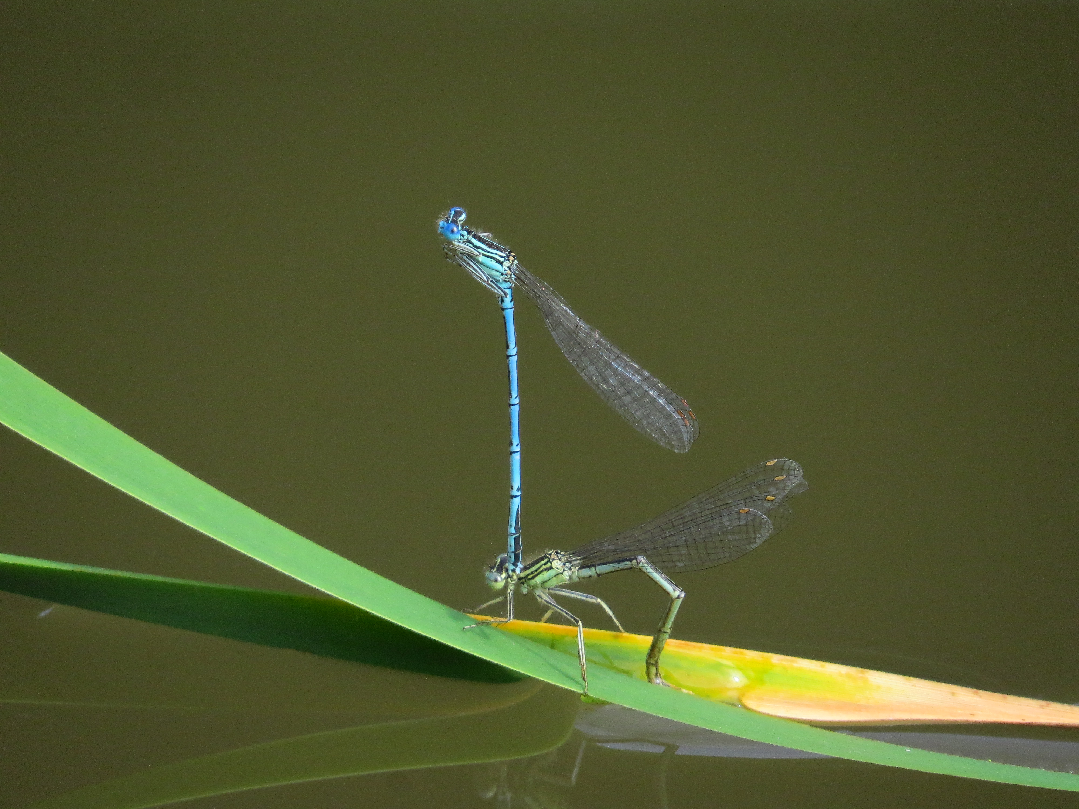

Melanistic Scarce Chaser- Bob Woodroofe


